Creating a template for Docx

1. Create a template with an arbitrary form
2. In MS Word go to the Developer tab and press Design Mode 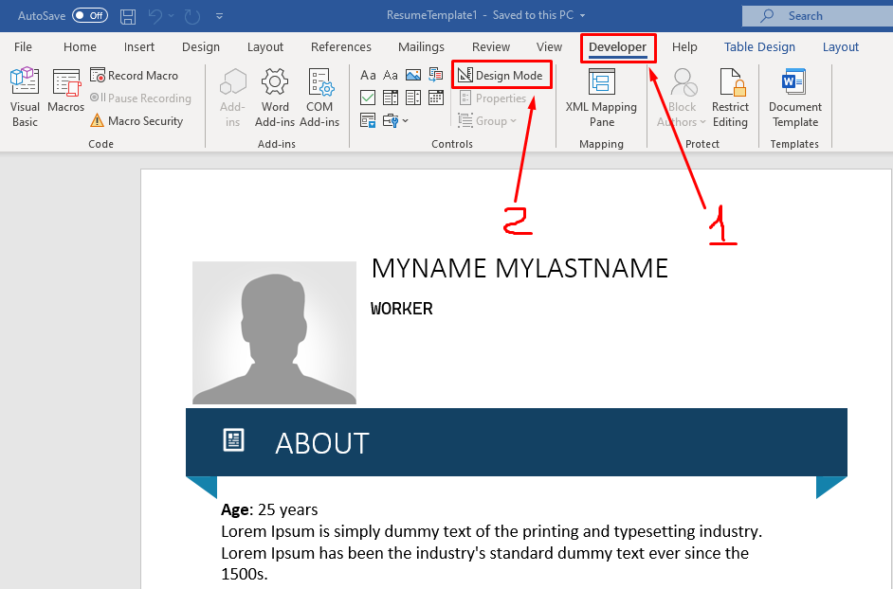
3. If you want to select text content to replace you need select this text and press button  on Developer tab 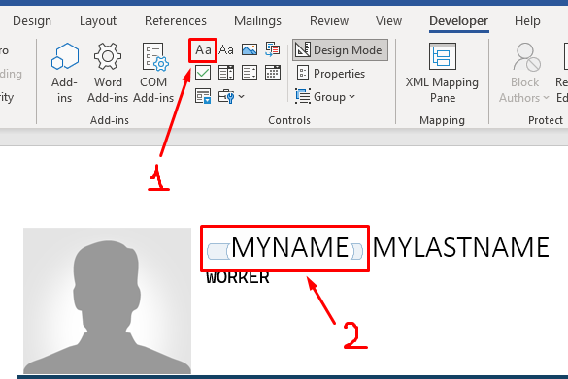
4. After need press Properties button and add tag name 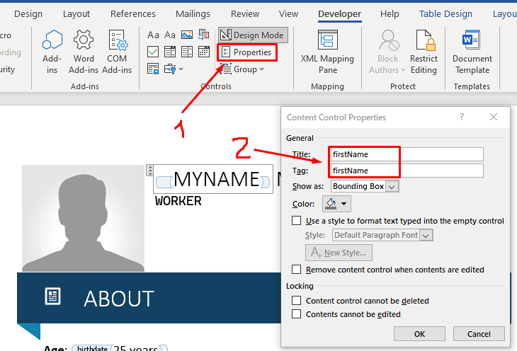
5. To select on tag replaced photo need select photo and press  button after that add photo tag name on properties 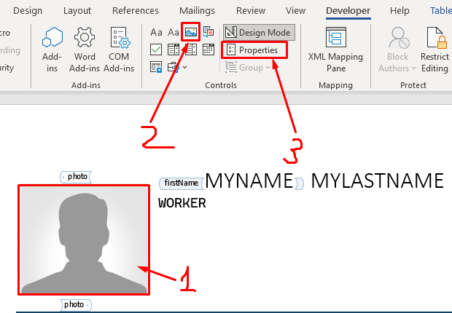
6. In the resume we have some blocks with level (Languages and Skills), for these fields we use a diagram. To create this block need create an example diagram and wrap this diagram on the tag 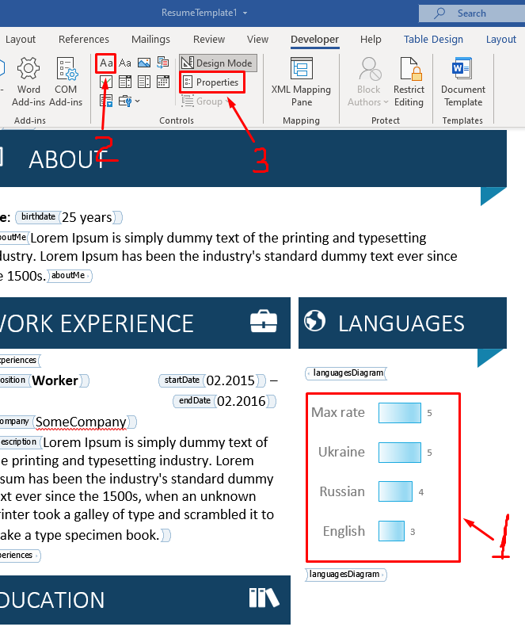
7. For Work Experience and Education we can have a few works or education spaces, on the template we need to create one example with fields and wrap this example on list tag 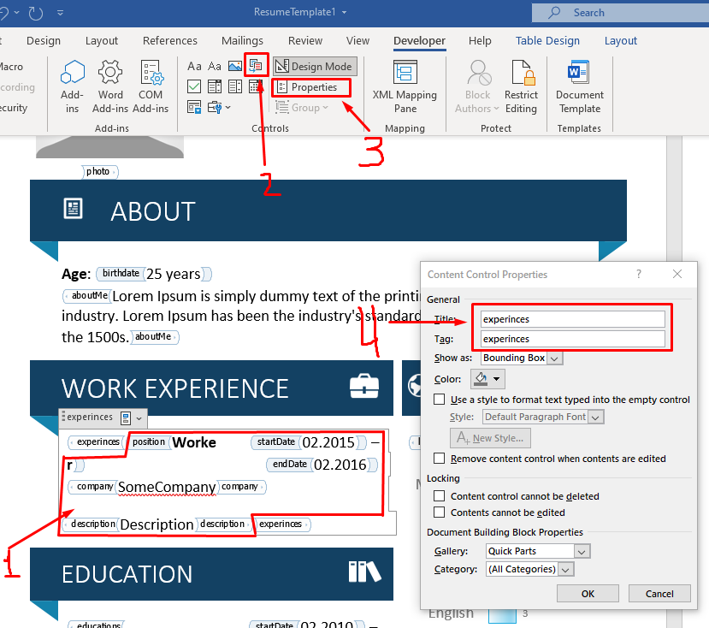
8. Text tags on resume:

* firstName
* lastName
* requiredPosition
* birthday
* aboutMe
* phone
* email
* code
* country
* city
* street
* site

Photo tag:

* photo

Diagramm tag:

* languagesDiagramm
* skillsDiagramm

List tag:

* experiences (position, startDate, endDate, company, description)
* educations (institutionName, startDate, endDate, specialization, description, degree)